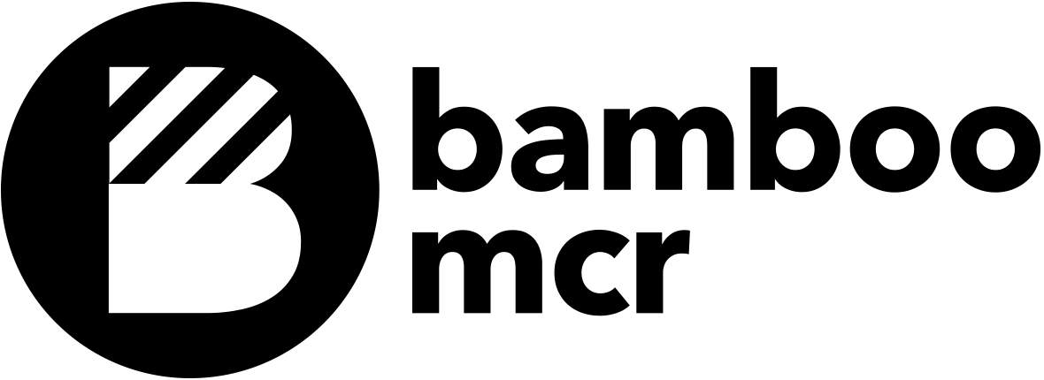

The Bamboo Brief

Why do we need a brief?

Our focus at Bamboo is to deliver a website that integrates into your business and becomes an invaluable asset. This brief is one step that helps us to do just that by asking a series of questions about your business and the objectives you want to achieve. Plus it’s a great place to kick start the creative processes. For instance, if you really don’t like the colour orange, then this is the time to make that clear - No Orange!

This brief isn't just for us. Once you've completed it you can pass it on to any other people within your business who have a vested interest in the outcome of the project and gain valuable feedback. That said the approval of work is best left to as few people as possible. A single point of contact who has the final decisions during the design and development process will give the project focus and clarity.

-

So go ahead and jump in. Answer what you can, skip what you can't and leave the rest to us.

Please introduce yourself

Name:

Company:

Address:

Telephone:

Email:

Think

Tell us a bit about your business / organisation

Describe your business/organisation and the products or services that you offer:

What industry does your business operate in? (e.g. recruitment, hospitality)

How are your products and services currently purchased? (e.g. retail outlet, magazine adverts)

What marketing techniques do you currently use to attract clients / customers? (e.g. print adverts, radio, Google AdWords)

On a scale of 1 to 10, where 1 is 'very cheap' and 10 is 'very expensive', where do you see your products / services?

On a scale of 1 to 10, where 1 is 'very traditional' and 10 is 'very modern', where do you see your products / services?

Who are your top three competitors online?

Website 1: www.

Website 2: www.

Website 3: www.

What are the key reasons for choosing your products or services over your competitions’? (e.g. cost, service, value)

Your Customers

Are your customers local, national or global?

Are your customers a specific gender?

Which age groups are you customers in? (18--24, 25-34, 35-44, 45-64, 65+)

Do your customers have a typical employment status? (e.g. unemployed, self employed, managing director)

Are there any ethnic considerations? (e.g. Primarily aimed at an Asian market)

Do your customers have any special interests, hobbies or values to consider? (e.g. primarily aimed towards motorcyclists)

Are there any specific disabilities we need to consider? (e.g. blind/partially sighted)

Design

The look and feel of your new website

To give us some idea of how you see your business, choose the options below that best describe your business (delete as applicable)

Traditional / Modern

Fun / Serious

Clean / Fancy

Simple / Busy

Friendly / Corporate

Local / Nationwide

Expensive / Value

As part of the project, we are happy to create or refresh your brand. Please choose the option that best describe your brand:

I have a brand that I am happy with

I have a brand but I would like the online version refreshing

I have a brand but I would like both the print version and online version refreshing

I don't have a brand and I would like one for my website

I don’t have a brand and I would like one for both my website and printed media

Finally, just to give us an idea of what kind of websites appeal to you, please list three websites that you like the look of:

Website 1: www.

The thing I like most about this website is:

Website 2: www.

The thing I like most about this website is:

Website 3: www.

The thing I like most about this website is:

Create

Your new website

Do you already own a domain name - if so which one?

Do you already have a website?

If the website could get one sentence across about your business what would it be?

Overall, what are you look for your new website to achieve? (e.g. increase in sales)

Would you like to sell products on your website?

What are the top five search terms you would like your website to come up for in searches?

Which sections would you like on your website? (delete as appropriate)

Home Shop

About us Contact

Services Terms and Conditions

Products Privacy Policy

News/Blog

Other (Please specify):

The website content

Who is responsible for delivering content for the project?

Are you able to provide all the copy for the website, or would you like us to help with the copywriting?

Are you able to provide all the required graphics for the website, or would you like Bamboo to create some awesome graphics for you?

Have you got all the photographs you want for the website, or should we send our photographer round?

Can you supply all the videos you want on the website, or do you want Bamboo to create them for you?

And finally.

What budget do you have for the project?

Are there any deadlines Bamboo need to be aware of?

Who has the final say on the design and approval of the project?

OK, we’re all done!

Now just drop this back to Bamboo

Send via email: hello@bamboomanchester.uk

or

Post it:
Bamboo Manchester
Ziferblat
23 Edge Street
Northern Quarter
Manchester
M4 1HW
Bamboo, Ziferblat, 23 Edge Street, Northern Quarter, Manchester M4 1HW
Telephone. 0161 465 3302 Email: hello@bamboomanchester.uk Website: www.bamboomanchester.uk

